Instructor | Adam Gold | Lesson no | 2 | Location | As appropriate
Date | As appropriate | Time | As appropriate | Duration | 45
Number of students | 30 | Year group | 1 & 2
 | Key stage 1 skill: Agility
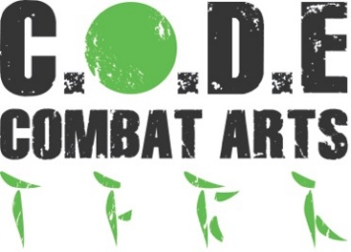
Example lesson plan: learning for Key Stage 1

Hunts Primary Level Martial Arts Lessons
All learners will be able to : | Some learners will be able to: | Few learners will be able to:
Understand the fundamentals of agility and the effects on the body with relation to basic martial arts movement | Undertake basic exercises and follow basic instructions relating to agility. Be able to connect fundamentals of agility with fundamentals of martial arts based movement in a few ways. Complete a few basic agility drills | Connect fundamentals of agility with fundamentals of martial arts movement in a variety of exercises as required. Complete and understand several agility drils
Key stage 1
Pupils should develop fundamental movement skills, become increasingly competent and confident and access a broad range of opportunities to extend their agility, balance and coordination, individually and with others. They should be able to engage in competitive (both against self and against others) and co-operative physical activities, in a range of increasingly challenging situations

Warm up – 10 mins | Main lesson – 30 mins | Cool down – 5 mins
Raise core body temperature And prepare body for main lesson:  - Consisting of a series of ‘races’ running the length of the hall with basic exercises at one end. Working together as a team as an added task  - Running in a large circle performing exercises at my request. Enhancing coordination as an added task | Key skills learned through game based activities, line drills and focus pad work  - Using equipment like ‘floor ladder’ or cones to undertake varying levels of agility drills  - Using Focus pads as a target for specific martial arts kicks, strikes and blocks.  - Copying instructor lead movements to understand techniques and how they are affected by balance | Activity to readjust the body after exertion to reduce build-up of bodily toxins and to cool down.  - Gentle movement and technique recapping  - Basic stretching exercises  - Question and answer session whilst sitting down.

Required | Equipment | Location
- School or CODE Combat risk assessment  - First Aider Instructor in attendance  - Children to train in PE kit and BARE FEET | - Focus pads/ kick shields/ floor ladder/ cones  - Sponge ball  - Floor mats  - First aid kit | Sports hall/ Dance studio with smooth/ flat surface and no trip hazards. This is an indoor activity.

